Student Name | Charles Meredith
Activity Type | Hacking Mobile Platforms / IoT and OT Hacking Lab

Instructions
Perform the labs per the instructions in the iLab’s environment.
- As you complete the tasks in the lab, insert a screenshot of the steps indicated below.
- Screenshots should contain unique information generated within the VM; this should include a shell (Bash in Linux, or PowerShell in Windows) with the output of the date command and your username typed below.
- Perform all the tasks shown below. Only provide screenshots for the tasks that specify a screenshot.

Tasks and Screenshots
Complete the following lab tasks in the Hacking Mobile Platforms iLab Module:

- Lab 1 – Hack android devices
  - Task 1 – Exploit the Android Platform through ADB using Phone Sploit-Pro
1. Screenshot step 40
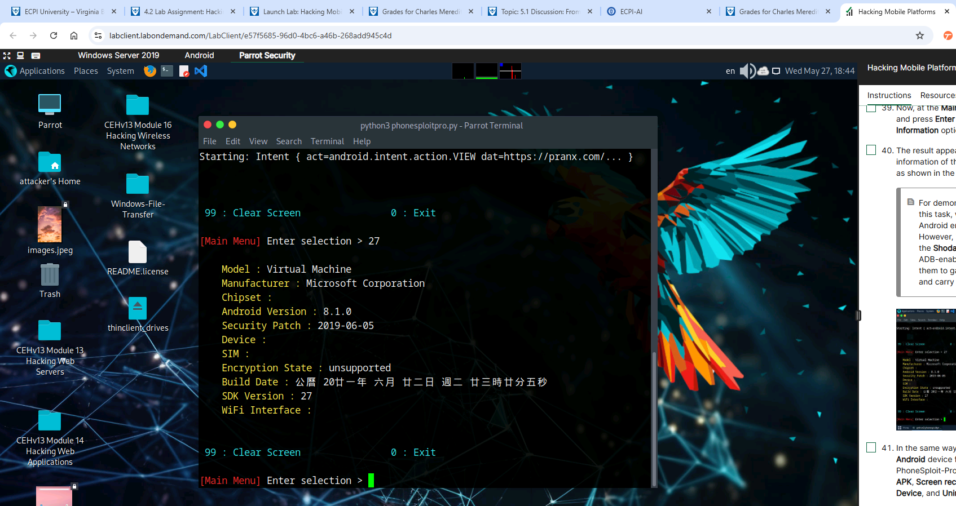
  - Task 2 – Hack an Android device by creating APK file using Andro RAT
    - Screenshot step 25
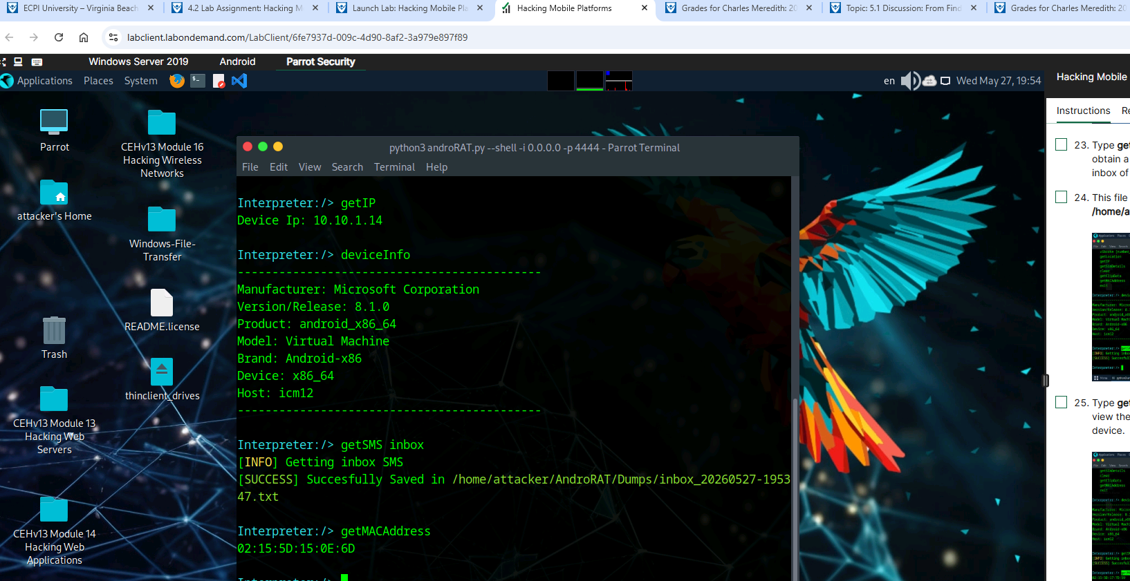
- Lab 2 – Secure Android Devices using Various Android Security Tools
  - Task 1 – Secure Android Devices from Malicious Apps using AVG
    - Screenshot step 8
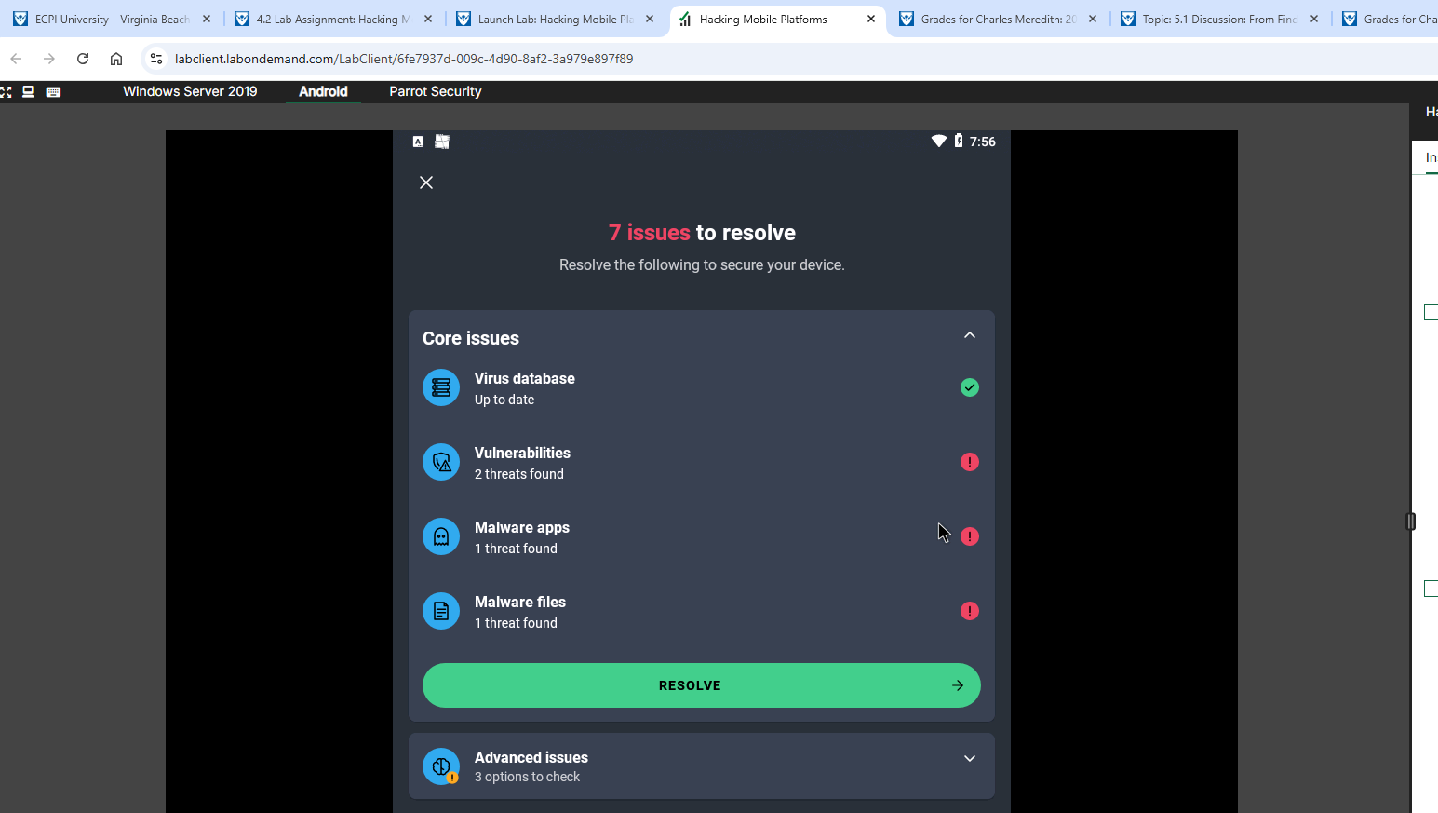
Complete the following lab tasks in the IoT and OT Hacking iLab Module:
- Lab 1 – Perform Footprinting using various Footprinting techniques
  - Task 1 – Gather information using online footprinting tools
    - Screenshot step 19
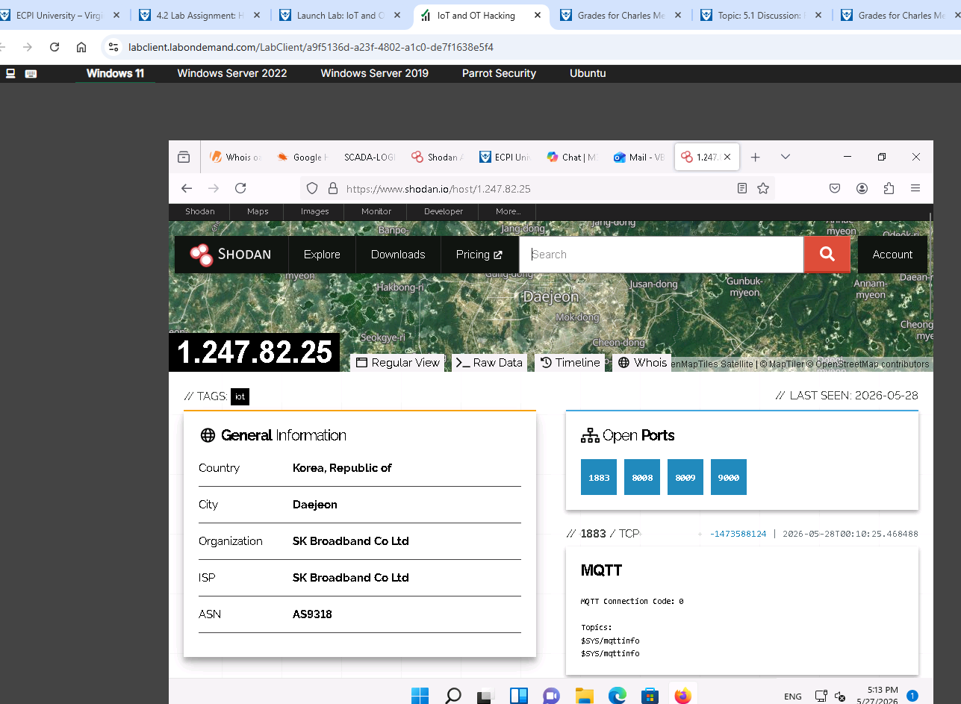
- Lab 2 – Capture and analyze IoT Device Traffic
  - Task 1 – Capture and analyze IoT traffic using Wireshark
    - Screenshot step 56
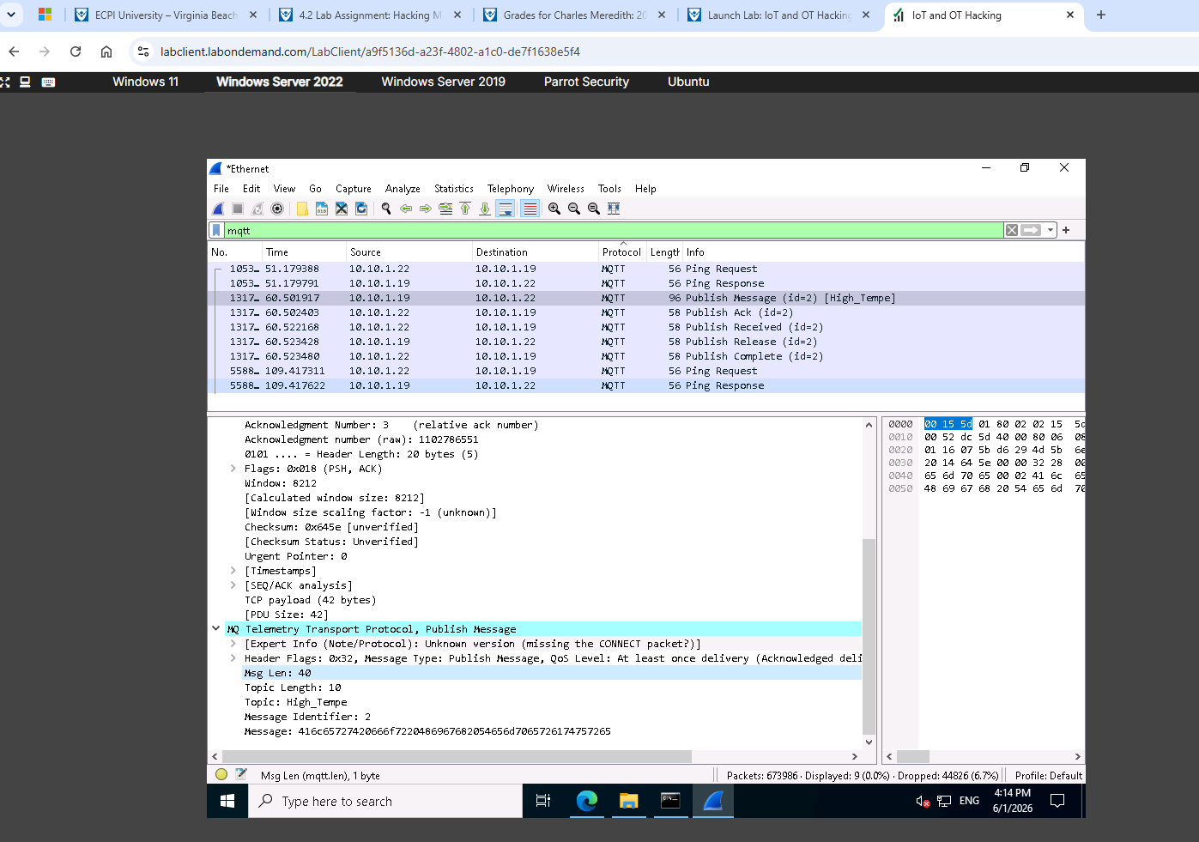
- Lab 3– Perform IoT Attacks
  - Task 1 – Perform Replay Attack on CAN Protocol
    - Screenshot step 16
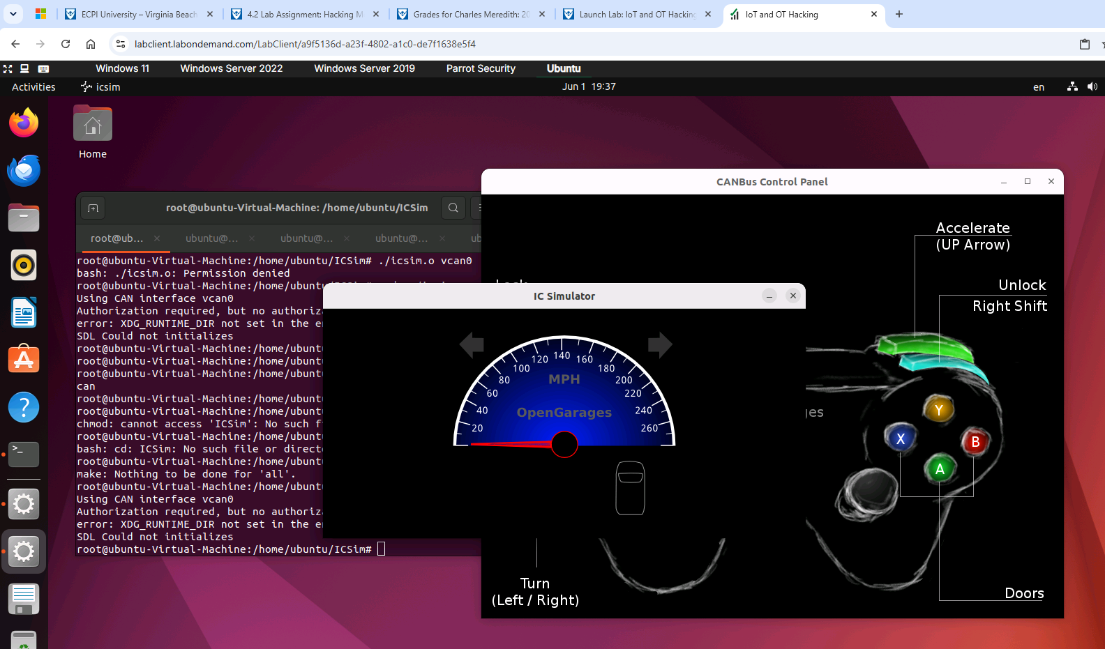

Summary
Write a few paragraphs summarizing the key skills you have acquired during this lab.

In this Lab we acquired many new skills. For example, we went through the process of exploiting the Android Debug Bridge by using the Phone sploit Pro tool. We also used a malicious android package using Andro RAT to establish a functional remote access trojan. We also used endpoint tools such as AVG mobile security.

In the second lab we did some open-source intelligence gathering using Shodan and Google Dorking to expose Operational Technology infrastructure to extract critical asset data such as open ports, device firmware and network banners. We also used CAN manipulation using ICSim and Vcan0 for the final lab. And we also acquired the procedural knowledge that allowed for the capturing of telemetry message frames like candump and injecting them back into the network using canplayer.

Review Questions
Answer the following questions.
1. Mobile security is becoming more challenging with the emergence of complex attacks that utilize advanced persistent threats to compromise mobile devices.
2. Owing to the extensive usage and implementation of Bring Your Own Device policies in organizations, mobile devices have become a prime target for attacks.
3. Android security tools reveal the vulnerabilities of Android platforms and devices.
4. Owing to a lack of security policies, Smart TVs are easy targets for hackers who can compromise these devices to spy on user’s activities, misuse sensitive information, install ransomware to block access to the devices, and monitor victims’ activities using CCTV cameras.
5. IoT Foot printing Tools are used to collect basic information about the target IoT and OT platforms to exploit them.
6. MQTT is a lightweight messaging protocol that uses a publish/subscribe communications pattern.
7. Potential vulnerabilities in the IoT system can result in major problems for critical infrastructure.

